Statistics Lecture 85: Hypothesis Testing for Population Mean. Population Std Dev is Unknown

* For claims involving the population mean when the standard deviation is unknown

Requirements:
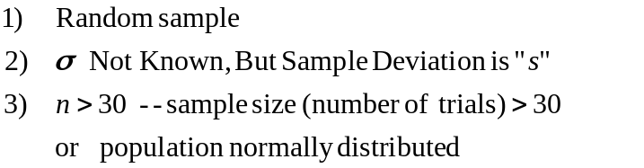

Sample standard deviation is denoted by: s 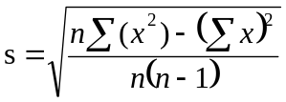
Test Statistic
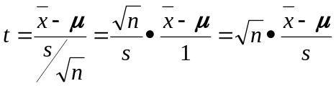

Traditional Method (p-value does not work well except with calculator)

Example
You sample 39 cans of soda. The mean volume of soda was 12.11 oz with a sample standard deviation of 0.27 oz.

Test the claim that the mean volume of soda is greater than 12 oz with a 0.01.

Step 1 Identify claim and opposite
Claim: 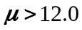
Opposite: 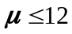

Step 2 Set up Null and alternative Hypothesis.
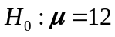
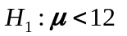

Step 3 Identify Significance Level
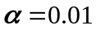 One tail

Step 4 Calculate the Test Statistic
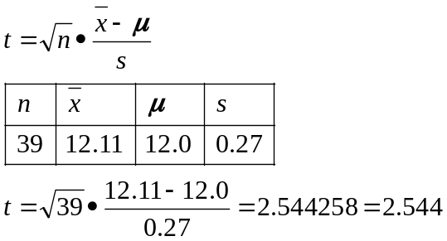

Step 5 Graph

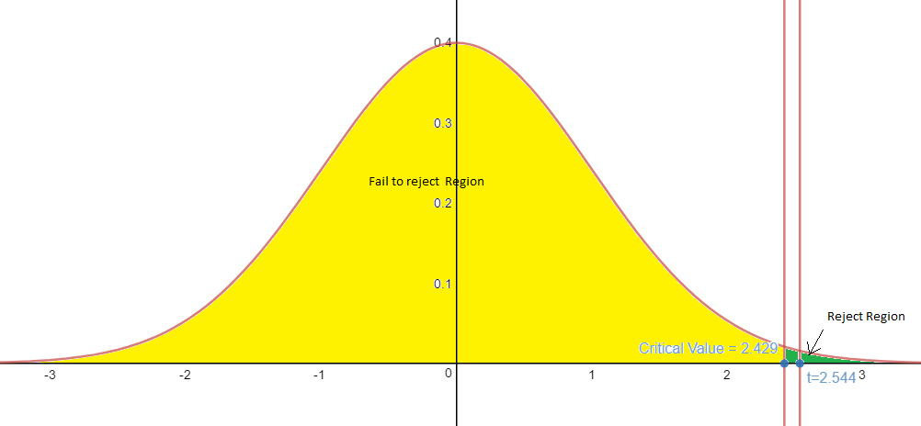

Test statistic ( t=2.544)
Right tail test
Look up the Critical value using value and the degrees of freedom using the t-table
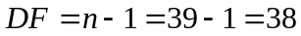

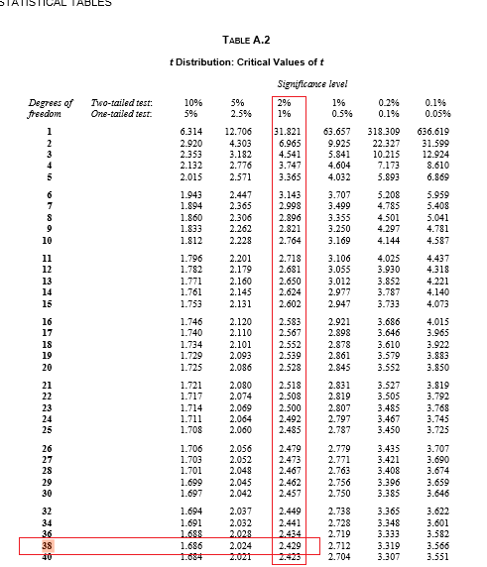
Critical value = 2.429

Step 6 Make a decision
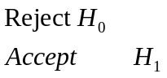
Since the test statistic 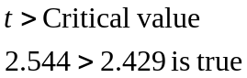

Step 7 Interpret
Reject 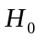 There is enough evidence to support the claim that the mean volume of soda is greater than 12 oz with a 99% certainty.

Example
You sample 39 cans of soda. The mean volume of soda was 12.11 oz with a sample standard deviation of 0.27 oz.

Test the claim that the mean volume of soda is not equal to 12 oz with a 0.01.

Step 1 Identify claim and opposite
Claim: 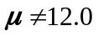
Opposite: 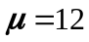

Step 2 Set up Null and alternative Hypothesis.
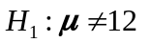

Step 3 Identify Significance Level
Two tail

Step 4 Calculate the Test Statistic

Step 5 Graph

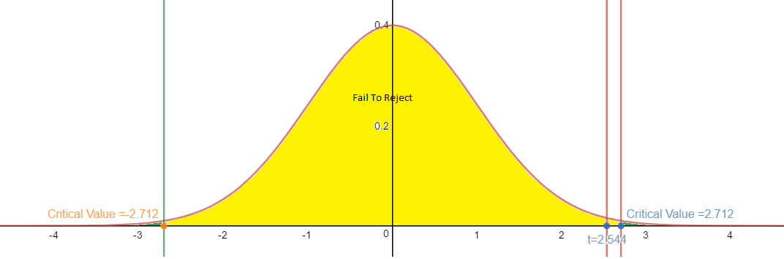

Test statistic ( t=2.544)
Two tail test
Look up the Critical value using value and the degrees of freedom using the t-table

Critical value = 2.712
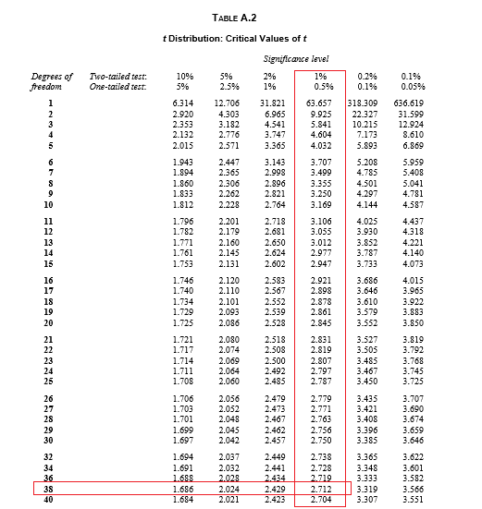

Step 6 Make a decision
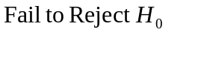
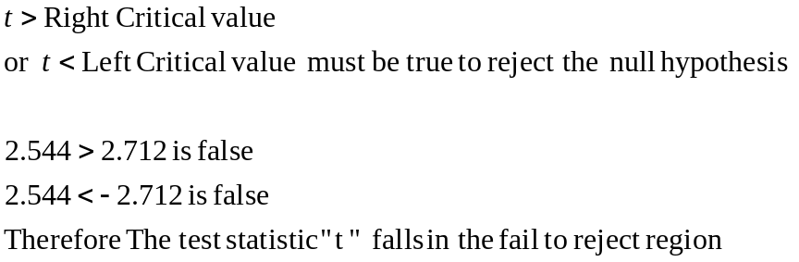

Step 7 Interpret
Reject There is not enough evidence to support the claim that the mean volume of soda is not equal to 12 oz.

Step 5 Graph Traditional

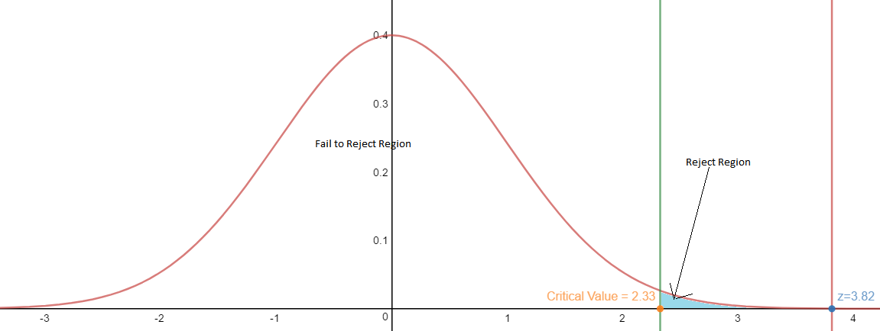

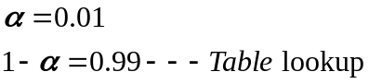 One tail

Critical Value =2.33
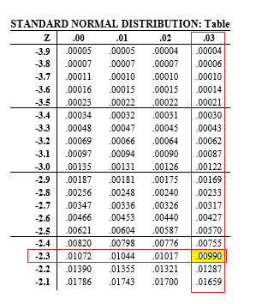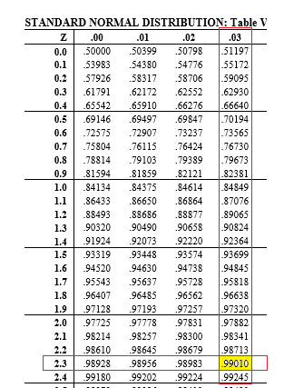

Step 4 Calculate the Test Statistic
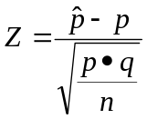
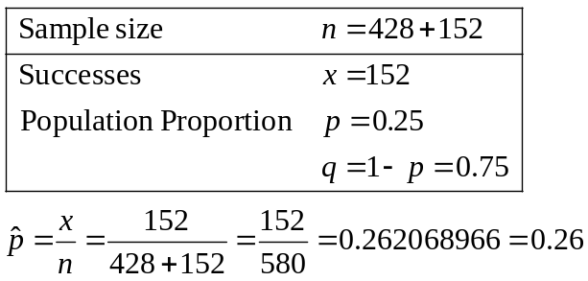

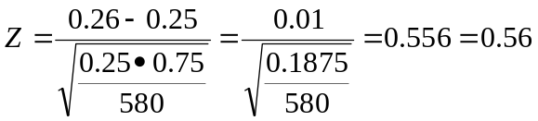
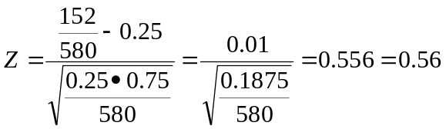

Step 5 graph
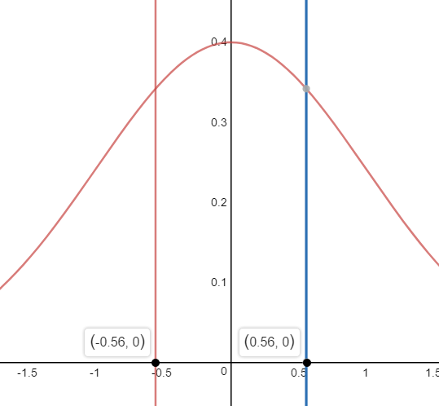
P-value is the area in the tail(s)
Area= 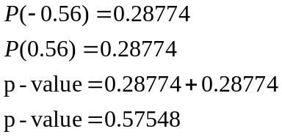

Step 6 Make a decision
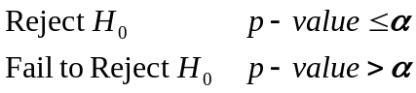
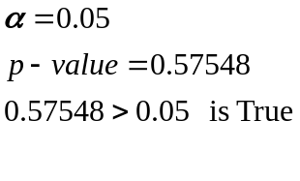
Fail to Reject therefore 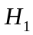 is unknown

Step 7 Interpret
Fail to Reject There is not enough evidence to support the claim that the proportion of yellow pods is equal to 1/4.
Step 5 graph (Tradition Method

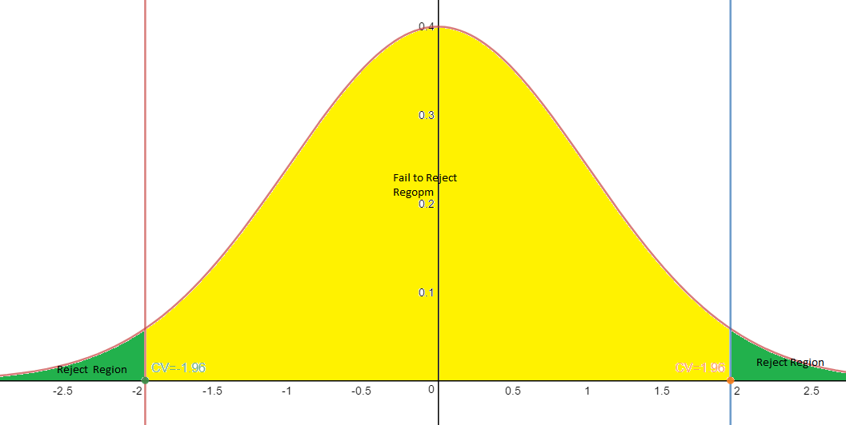
P-value is the area in the tail(s)
Area= 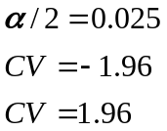

Step 6 Make a decision
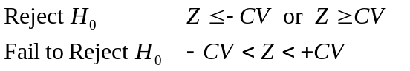
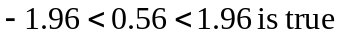
Fail to Reject therefore is unknown

Step 7 Interpret
Fail to Reject There is not enough evidence to support the claim that the proportion of yellow pods is equal to 1/4.

